**Group Task Assignment 4 Matt Doolin, Amit Singh, Kyle Thomas, Fei Xu**

**14/16 points**

**Section 1**

1. Yes there is evidence of imbalance from the logit output and the quick means comparison/t-test. The table below shows the results from the logit model and two question variables were significant: question D_420_3 and question D_4701.2_1.

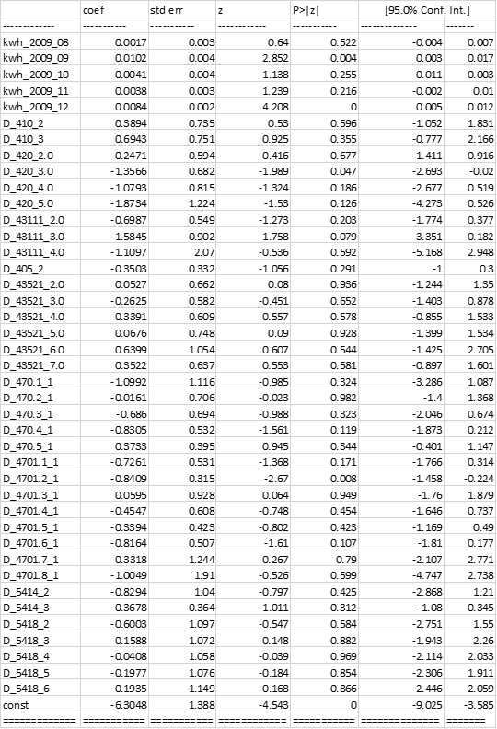

The t-test from the quick means comparison showed seven variables that had t-statistics with an absolute value greater than two and they are listed below.

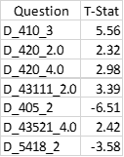

What about the consumption variables?! Those were clearly biased! -2 pts.

1. Results between the two models are quite different. None of the variables that are significant between the two outputs match. High collinearity problems could be driving this difference as the logit model was not corrected for collinearity. Collinearity creates larger standard errors, reducing significance. This is evidenced by the fact that there were more significant variables identified by the t-test than the logit test.
2. Logit is a faster way to check for imbalance than conducting the quick means comparison and t-test, especially for looking across multiple variables. As a con, logit includes interactions between all other included variables that could influence the significance of each due to collinearity problems. The quick means comparison is useful as a first step to determine if a test for imbalance is needed at all. If there are no abnormal values, then the data can be used as is. However, it is more complicated and time consuming to complete as .?? It is not that much more complicated if the data is set up right.
3. Some of the questions selected were redundant and could have led to collinearity problems. For example, the three questions of how many people lived in the house total, how many people are under the age of 15, and how many people over the age of 15? All these are related and would not be necessary in the same regression.

**Section 3**

1. The value of TP increased from -0.008 without weights to -0.0253 with weights. This represents an increase by a factor of 3.16 when the weights were added. Similarly, the value of p increased from a value of -0.0201 without weights to -0.0222 with weights. This represents an increase by a factor of 1.10 when the weights were applied.
2. Without weights applied the logit model suggests that consumption decreased by 0.8%. However, the p-value of TP was 0.537, which means that the result is not statistically significant. Therefore, we would conclude that the C4 treatment was not successful.
3. With the weights applied the logit model suggests that consumption decreased by 2.5%. Additionally, the p-value of TP, when the weights are applied, was 0.009 implying that the result is statistically significant. Therefore, we would conclude that the C4 treatment was a success.
4. We believe that the coefficient results of the weighted regression can be believed. The weighting determines the magnitude of the imbalance and reweights the observations to correct for the imbalance. However, in order to know whether the coefficients are truly significant, we would first need to account for the fact that demeaning reduces the standard errors. If after correcting the standard errors, the p-values were still significant, we would have more confidence in our coefficient estimates.

The more important thing would be to check if, by using different variables in the logit stage, the TP coefficient changes drastically. The logit stage is can be very sensitive to which variables are used when calculating the weights.